**Cognitive Deficits in Epilepsy: Data Analysis**

Bryce Whitcomb

NEU 494: Data Analysis in Neuroscience

April 20, 2023

**Introduction**

This project was made to visualize and analyze the different cognitive deficits that can occur across different types of epilepsy. The data used in this project comes from a study titled “Cognition and epilepsy: Cognitive screening test,” which was attempting to obtain comprehensive data on the cognition of people with epilepsy. This project is intended to take that data and provide charts and discussions to further analyze and explain trends and shortcomings in the study.

**Background**

Epilepsy is a neurological disorder which is characterized by chronic seizures. Seizures are abnormal brain activity that usually comes in the form of the excessive firing of neurons. There are several different types of epilepsy and multiple types of seizures as well. The data from this study (Tedrus, G. M., Passos, M. L., Vargas, L. M., & Menezes, L. E., 2020) separated its participants into four groups based on their epilepsy onset; these groups being: genetic, focal unknown etiology, focal structural, and a control group.

The categories of epilepsy used in this study are somewhat simplified types of epilepsies that categorize subjects based on the types of seizures they have. While there are dozens of specific epileptic conditions that can vary greatly from each other, these main three categories of epilepsy provide a good means to group the patients in the study. Genetic epilepsies are epilepsies in which the cause is innate to the person. Focal structural epilepsy is epilepsy in which there is a physiological and identifiable source of the seizures, typically originating in a specific lobe or region. Focal unknown etiology is epilepsy in which the cause for the seizures results from a physiological source, but the region of the nervous system producing the seizures is unknown; this type of epilepsy can also be associated with regions outside of the central nervous system.

Individually these different types of epilepsy each have different traits associated with them. They have different onsets, severities, and cognitive impairments. This study was made to quantify these differences and create a cognitive screening test that is specifically suitable to epilepsy patients. This data also provided results that can help distinguish cognitive deficits that are variable across these different types of epilepsy.

**Methods**

The study was conducted on a total of 371 people with epilepsy and 95 control subjects, all of whom were adults over the age of 18. They were all submitted to a cognitive assessment testing several different areas of cognition. The participants were asked to fill out a questionnaire whilst connected to an electroencephalogram(EEG). They were then subjected to a mini-mental state examination (MMSE) which measured their “cognition that assesses orientation, basic attention, working, learning, naming, construction, comprehension, and repetition memory”(Tedrus, G. M., Passos, M. L., Vargas, L. M., & Menezes, L. E., 2020). Finally they underwent a cognitive assessment in which they had to identify and recall images shown to them, this process was repeated multiple times with the same images with different delays. They were also given a clock drawing test. In all of these cognitive assessments they had to identify the correct images they were shown before amongst several distractor images.

My program and presentation was designed to take the data resulting from these tests and present them in meaningful and easily digestible figures. Furthermore, I attempted to discuss specific correlations and unexpected outcomes in the data.

My methods for using the data from the study consisted of pulling all of the data from their individual spreadsheets, then displaying the data and performing some algorithms to make specific results more comprehensible and comparable to one another. For example, in table 2 in my paper I pulled the data from the spreadsheet “occurrence”, which contained all of the information regarding whether or not there was cognitive impairment in specific participant groups. I made a simple algorithm to pull specific data from the dataframe and calculate the proportions of impairment and no impairment for each group.

**Data**

This study provided a lot of raw data that was organized suboptimally for finding specific correlations. When presented with the raw data from the study there are several confounding variables that will likely need to be addressed in future studies.

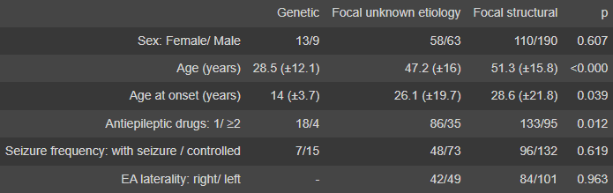

Table 1 presents data persisting to general information about the subjects from the study. The column “Genetic” refers to the subjects who had epilepsy with genetic etiologies, “Focal unknown etiology” refers to the subjects who had epilepsy with no secondary diagnosis for the cause of their seizures, and “Focal structural” refers to the subjects who had epilepsy in which seizures begin in specific region(s) of the brain.

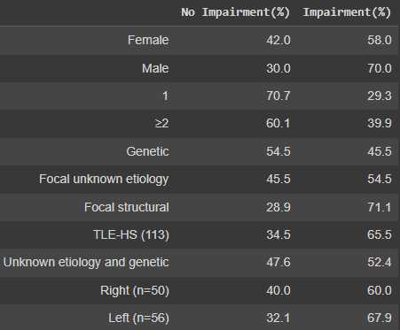

Table 2 provides data from the study which categorized whether or not the subjects experienced any cognitive impairments. This data represents the subjects’ general information and their proportions of no impairment and impairment.

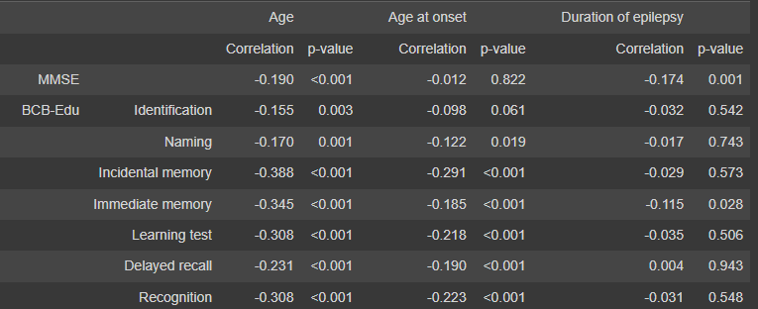

The data in table 3 presents the specific tests which were conducted in order to determine if there was any impairment in the subjects or not. This data was cross referenced with the age of the subjects, age of epilepsy onset, and the duration of epilepsy in order to determine any correlation with task performance when compared to the control group of non-epileptic subjects.

**Results**

Table 1 provides general information regarding the subjects used in the study, however it does also provide some information regarding general trends for epilepsy and information that is important for understanding the rest of the study. Genetic epilepsies tended to have earlier onsets, which could also cause them to show greater impairment. Focal unknown and focal structural epilepsy subjects both tended to have their epilepsy for longer periods of time, which could also result in greater impairment. Subjects who reported taking two or more antiepileptic medications were proportionately more likely to be without recurrent seizures.

Table 2 showed correlations between several characteristics and whether or not subjects had cognitive impairments in the study. Male participants were proportionately more likely to show impairment than Female subjects. Subjects taking two or more medications showed more impairment than those taking only one. Focal structural epilepsies had significantly higher rates of impairment. Subjects with Temporal lobe epilepsy with hippocampal sclerosis (TLE-HS (113)) also showed disproportionately high rates of impairment. Left hemisphere epilepsy also had a slightly higher rate of impairment when compared to right hemisphere epilepsy.

Table 3 showed the correlation between impairment and subject age, age of onset, and duration of epilepsy. Nearly every task had a negative correlation, meaning they all

showed impairment. The biggest determinant of impairment seemed to be age, which had the most negative correlation across all tasks. Age at onset and duration of epilepsy seemed to have

inverse correlations of impairment; when one showed a more negative correlation the other had a relatively positive correlation.

Overall the data from this study shows clear correlations between epilepsy and cognitive impairment. Further studies are needed to determine further correlations however. Some confounding results occurred, such as an increased rate of impairment in subjects who took two or more medications, despite them also being less likely to have recurrent seizures.

**Summary**

The data provided from this study is a great tool for analyzing the different cognitive impairments that can occur across different types of epilepsy. By creating different dataframes The raw data from this study can be further analyzed to draw new conclusions and create new questions. Despite a few issues in the recording and categorization of data from the study, the results provide a basis for many different data analyses. As more studies of this nature take place, the cognitive impairments and potential treatments of epilepsy will continue to be further understood.

**Sources Cited**

Tedrus, G. M., Passos, M. L., Vargas, L. M., & Menezes, L. E. (2020). Cognition and epilepsy: Cognitive screening test. Dementia & Neuropsychologia, 14(2), 186–193. https://doi.org/10.1590/1980-57642020dn14-020013

Aldenkamp, A., &amp; Arends, J. (2004). The relative influence of epileptic EEG discharges, short nonconvulsive seizures, and type of epilepsy on cognitive function. Epilepsia, 45(1), 54–63. https://doi.org/10.1111/j.0013-9580.2004.33403.x